**Lesson 7 Demo 4**

**Ansible Facts**

|  |
| --- |
| **Objective:** To implement playbook containing facts  **Prerequisites:** You need to have Python 2.7 or higher, minimum 8 GB RAM, and SSH or SCP communicator.  **Tools required:** Ansible |

**Steps to be performed:**

1. Running playbook containing facts

**Step 1: Running playbook containing facts**

* 1. Create a playbook file using **sudo nano playbook.yaml** which updates software packages on all hosts as shown below:

**---**

**- hosts: all**

**become: yes**

**become_user: root**

**become_method: sudo**

**tasks:**

**- name: install update (apt)**

**when: ansible_distribution == "Debian"**

**package:**

**name: apache2**

**state: latest**

* 1. Run the command below:

**ansible-playbook playbook.yaml**

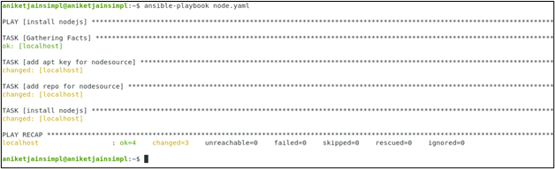

After checking all the dependencies, Apache2 is successfully installed.